Digital Avatar

**Health**

Now imagine a virtual human not made of flesh and bone and not just any human but a virtual version of you, accurate at every scale from the way your heart beats down to the letters of your DNA code. Many drugs only work well on some people and can cause serious side effects in others. The reason is variations in DNA, our genetic differences. We understand how these DNA differences change the building blocks of your body, the proteins and we can simulate in a computer how drugs interact with them. By testing drugs on your virtual body your doctor may eventually be able to test a wide range of drugs and select precisely the right one to suit you.

Take drugs for instance which can end up in the walls of your nose, or at the bottom of your lungs depending on the intricacies of your particular respiratory system using a supercomputer. Simulation based on your lungs we can predict with high precision where particles will flow and then design devices that can deposit drugs exactly where your body needs them.

Virtual humans could help doctors to plan risky surgery too. They could be used to work out how to reach an aneurysm deep in the brain that is at risk of rupture which could cause a stroke.

The CompBioMed Centre, is developing a programme that creates a hyper-personalized avatar or ‘virtual human’ using a supercomputer-generated simulation of an individual’s physical and biomedical information for clinical diagnostics. Greater access to technology-enabled healthcare will allow doctors to make better and faster diagnoses – and provide the tools to collect the necessary data. The Virtual Human project combines different kinds of patient data that are routinely generated as part of the current healthcare system, such as x-rays, CAT scans or MRIs to create a personalized virtual avatar. This enables doctors to provide more precise diagnostics, develop healthcare interventions based on a patient’s specific physiology, and run personalized medicine and clinical simulations for effective treatment. Using a patient’s own individual avatar, clinicians and researchers can test the effects of different drugs in order to select the most effective; and clinicians and device manufacturers can visualize how best to deliver a drug exactly where it is most needed.

Simulating a patient’s circulatory system and the movement of red blood cells produces insights into important processes such as those that prevent blood loss after an injury. And with cardiovascular disease accounting for half the sudden deaths in Europe, in future, virtual hearts beating inside supercomputers will reveal the detailed workings of individual patients to better understand the disease and test the effects of different drugs and pacemakers.

Said by Prof. Andrea Townsend-Nicholson, who runs one of the academic research groups working on the Virtual Human project, told ITU.

At present, the Virtual Human project is focusing on three aspects of bio-physical health and medicine:

* Neuromusculoskeletal: The computer codes used to assemble the neuromusculoskeletal Virtual Human use Finite Element Methods and Finite Element Analysis to analyze forces and strain distribution, looking at how to minimize biomechanical stress in an effort to avoid bone fractures.
* Molecularly-based medicine: The molecularly-based medicine computer codes are primarily molecular dynamics, a computational simulation method that is used to predict the movement of atoms and molecules in a system over a period of time. By looking at the structure of a protein, it can predict how the protein will change shape in response to a particular medication. Hence, doctors can determine which drug will be the most effective treatment. It will also help clinicians design new, more effective, medicines.
* Cardiovascular: For cardiovascular work, the computer codes use powerful computational fluid dynamics methods that can simulate complex geometries in a straightforward way.

Prof. Townsend-Nicholson said in interview that the US, China, Europe and Japan are all in the process of building exascale supercomputers – a thousand times more powerful than the petascale machines, able to make a quintillion calculations per second – which will have the necessary computational power to build individual Virtual Humans for everyone.

In a previous study, the Clemson University community developed a medical virtual reality training system to help nurses identify the signs of rapid patient deterioration. While developing the system, the Clemson University community worked closely with medical experts to create accurate virtual humans based on actual patient data. In this work, they used this system to study how different rendering techniques (realistic and nonrealistic) emotionally impacted participants. Clemson University community empirical evaluation adds to the current understanding of the effects of visual fidelity of virtual humans on human emotional responses. The experiment presented the participants with one of three conditions, one realistic and two non-realistic (Cartoon and Sketch). In the Realistic condition the patient is rendered using textures modeled after real patients including details such as wrinkles and blemishes. The Cartoon condition was rendered using a toon shading technique with flat colors and black outline. The Sketch condition was rendered using a custom built shader to give the character a hand-drawn sketch like appearance which used a cross hatching technique negative effect scores seem to increase over the timestamps for all participants in all rendering conditions. Although, when we compare the positive affect score, participants in the Realistic condition seem to elicit significantly higher levels of positive emotion in many of the time-steps of interaction than participants in the Sketch and Cartoon rendering conditions (p < 0.001). It seems that participants take a higher level of interest in the Realistic Bob condition, as compared to the stylized Bob conditions namely Sketch and Cartoon rendering conditions.

**THE VIRTUAL HUMAN BREATHING RELAXATION SYSTEM:** The core mechanism of the Virtual Human Breathing Relaxation System is the influence – entrainment – of the breathing rhythm using an ecologically valid physiological signal observed by the user. In general, entrainment refers to the oscillation of one system being influenced by the oscillation of another system. In the case of passive entrainment, the external pacemaker is set to a fixed frequency independent of the frequency of the target system. At the mechanistic level, breathing entrainment means that the effective breathing frequency is the result of the combination of the internal pacemaker for the breathing oscillation and the external synchronizer (Figure 1). In active entrainment, the oscillation of the target system is recorded, and the controller system then adapts the rhythm of the external pacemaker such that it can change the target rhythm gradually over time, continuously delivering a signal of optimal influence. In the Virtual Human Breathing Relaxation System this concretely means that the virtual human starts at a pre-set breathing rate and the human – the target system – breathes at a different breathing rate (Figure 1, two waves). Based on the user’s breathing frequency, the control system, in turn, adapts the breathing frequency of the virtual human. Once synchrony is achieved, the breathing frequency of the virtual human is then changed gradually, “dragging along” the user’s breathing rhythm until the desired frequency is achieved.

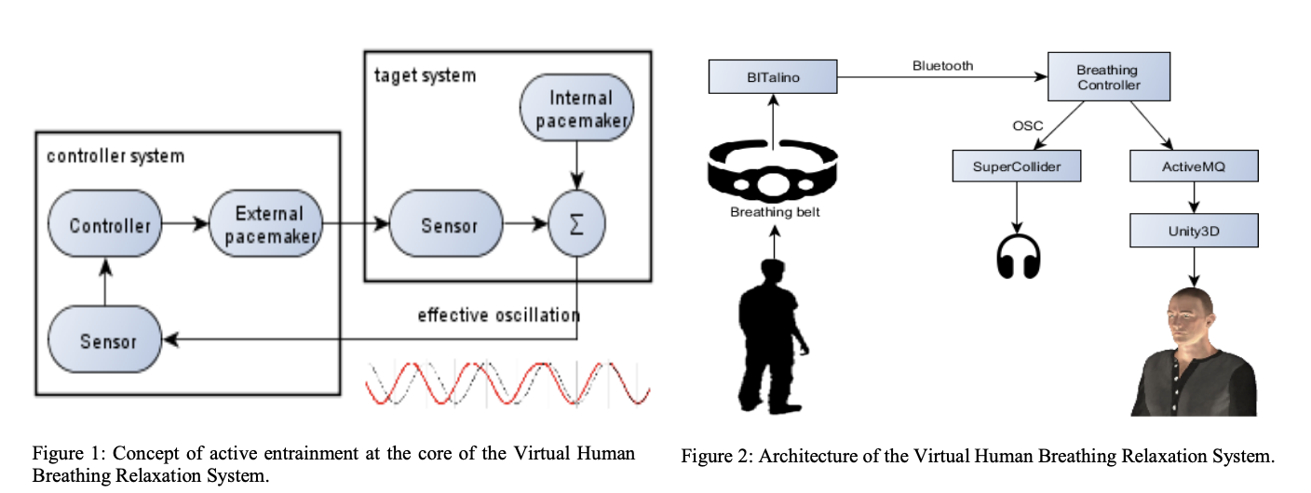

The demo works as follows: The participant is equipped with a virtual reality head mounted display, headphones, and breathing sensors around the chest and the abdomen. In the virtual environment, they meet the breathing virtual human standing in a room and showing realistic breathing behavior, i.e. chest/thorax movement, and inspiration/expiration sounds. The breathing of the virtual human swaps between fast and slow breathing phase. No verbal commands or instructions with regards to breathing are given to the demo participant. During the demo session the virtual human then continuously (a) perceives the human participant’s breathing pattern, (b) adjusts its own breathing pattern to closely mimic participant’s breathing, and (c) gradually changes its breathing rate in an attempt to influence the participant’s breathing. This closed-loop interaction is repeated until physiological synchrony between the participant and the virtual human is achieved to induce a relaxed state.

**Psychology**

Behavior confirmation theory (Snyder & Swann, 1978; Snyder, Tanke, & Berscheid, 1977) predicts that when a perceiver believes that the target thinks that he/she is interacting with is attractive, the perceiver behaves in a way which is consistent with the target’s expectation. In other words, when person A has an interaction with person B who believes that person A is attractive, person A behaves in a confident and friendly way, which is how physically attractive people usually behave. Therefore, regardless of a target’s behavior, a physically attractive person behaves in confident and friendly ways, thus conforming to the target’s expectations. Based on this framework, Yee and Bailenson (2007) found empirical support for the “Proteus effect,” which can be summarized as follows: Just as people change their behavior by simply changing wardrobes in an offline context, the different looks of avatars will have a significant impact on avatar users’ behaviors online. In a series of experiments, they found that when users were assigned to attractive avatars, they showed greater confidence and higher self-disclosure. For example, when users see their avatars as being attractive, they think that they are really attractive, and then behave in the confident and friendly way that attractive people are expected to behave. In addition, when they see their avatars as being old, they show more positive attitudes and less negative biases toward the elderly (Yee and Bailenson, 2006). Like in role playing, different faces on an avatar influences a user's self-perception and behavior. Cognitive dissonance theory (Brehm & Cohen, 1962; Festinger, 1957; Wicklund & Brehm, 1976) and self-perception theory (Bern, 1972) also support this idea by arguing that the public display of the self carries over to subsequent private self-appraisals and, in turn, influences one's public behavior.

Regardless of how the created avatars look objectively, avatar users are more likely to be aware of their own "self" in virtual environments, which consequently could influence their private behaviors, particularly health behaviors to preserve the self.

And finally one may ask: What benefits can we obtain from avatar customization? Can your avatar really improve your health? The present findings suggest that avatar customization may successfully transfer the psychological benefits obtained from customization to one’s well being. In VE, particularly where people communicate with others through their avatars, avatars are like windows to look at the world as well as mirrors to reflect the self, both of which enable users to focus more on the self. The awareness of the self is an important aspect of sense of agency, which drives motivations for self-preservation behaviors. It is, therefore, important to understand that an avatar’s identity cues, which may facilitate the transfer of the psychological benefits from customization to the self’s wellbeing, is determined by the user’s self-concept, not by the physical appearance of the avatar.

**Gaming**

Online gaming is consistently changing with the use of new technologies and seen as making an impact on consumers’ sustainable lifestyles. The gaming avatars have influenced low avatar identification players to engage in physical and learning activities through massively multiplayer online (MMO) game genres. The fundamental purpose of the study is to classify the association of an avatar with the consumer's behavioral intention for exercise and to consume healthy food. This study incorporates three theories: social cognitive theory (SCT), social determination theory (SDT) and player-avatar identification (PAI) theory to determine its four dimensions’ impact on exercise and healthy food intention to attain a sustainable healthy lifestyle.

In recent decades, online role-play gaming that is massively multiplayer online (MMO), massively multiplayer online role-playing game (MMORPG), role-playing game (RPG) and augmented reality games play has increased among adolescents. Moreover, it is inducing youngsters to engage in diverse physical activities that can benefit them in the form of learning and a healthy, sustainable lifestyle.

Sustainability also has many applications in different aspects, such as learning and education. Sustainable healthy lifestyle is also essential for consumers’ wellbeing, which can also be part of gaming if a gaming avatar can influence them. Gaming and sustainable healthy lifestyles can go side by side. Then again, it depends on which game genre can influence gamers to perform and make the decision for physical tasks.

Games study has revealed that players’ playing with others and in clans are more positively loud in social connections. Previously, a study focused on MMORPG explained many findings related to behavior and learning during the gameplay. Such games genre does provide learning and entertainment with a commercial purpose, but they also are the source of dangerous behaviors and aggressiveness.

For example, A quick Internet search will uncover numerous news reports depicting driving, biking, or walking accidents associated with playing *Pokémon GO*. Other stories depict players trespassing or placing themselves in dangerous environments or situations so they can catch more Pokémon.

Or the game named Second life. The purpose of Second Life isn’t to gather as many gold coins as possible or figure out a mission set by a wiry old wizard. Instead, it is simply a digital escapist fantasy that allows users to be whoever they want and do whatever they want away from the restrictions of the real world. While the possibilities were endless in Second Life, one phenomenon was quick to surface; that normal people submersing themselves in the game were acting pretty much the same as they would in real life. Yes this made it a fascinating environment to study the social behaviors of other people in a pre-built stage.

And finally for the most part, people used this game to escape reality and… do pretty much the same as they were doing in their real lives.

Learning-based games with entertainment have shown effective results concerned with learning and health through the use of different technologies. Some gamers like to play games where they do not have to perform physical activities, and that could affect having lousy health among adolescents and increase weight among children. Gaming Avatars perhaps can set the tone of the game with self-motivation factors to work hard and be like an avatar. Sustainability ideology is gaining awareness, and some firms are applying sustainability concepts.

Anthropomorphic avatars are found to be more uncomfortable and unappealing towards consumers when it comes to identity, i.e., anthropomorphic means characters that are more human-like animals or animals with special abilities. In gaming, previous results show that avatars that are presented as lifelike with masculine physiognomies even in cartoon form are fascinating. Such avatars are more dependable and worthy and are more likely to be preferred for representation in the game atmosphere.

Experts Li, Lwin and Jung explain that avatar perceptions in online games have influenced children in working on their body size and weight. It means that avatars can play a vital role in persuading consumers to do exercise and eat healthy food to stay fit. Avatars with standard body shape and size have a good effect compared to those with a massive physique. Peña and Kim explored that gamers are exhibiting the same average body weight as their avatars showed good results in physical outlook. The primary purpose of this study is to explain two things. First, to understand that avatars can influence consumers to do exercise and get in shape in the MMO. Second, progress an idea of the impact of avatars on consumers’ preferences to choose healthy food.

**Social Cognitive Theory (SCT)**

One theory that is used herein relates to psychosocial factors for online games, and avatars identification is the social cognitive theory (SCT). The theory states that individuals have the aptitude to process the information according to their will and further adds to cognitive activity that empowers them to absorb information and knowledge. Human cognitive processes are dependent on their self-efficacy, personal goals and environments. Gamers can merge themselves with an immersive experience of the game and may believe that they are the actual avatar through self-presence and find enjoyment in this process of believing that they can be like their gaming avatar.

**Social Determination Theory**

This theory states the learning of human motivation and behavioral aspects. Social determination theory (SDT) further can be classified into intrinsic motivation, extrinsic motivation and amotivation. Environment, people and nature motivate consumers to perform tasks in their daily life. In a virtual world, consumers can also be self-motivated, and self-efficacy measures can determine their choices to do different activities. The amotivation is related to light self-motivation, whereas intrinsic motivation states a sense of strong self-motivation. The extrinsic motivation is further divided into four components that attain a reward (praise), introjected (high self-esteem), identified (according to one’s personality) and integrated regulation (volitional). Immersive experience can engage consumers in online video games and may produce favorable outcomes concerning avatar identification and lifestyle. Self-presence can determine how one is and as an avatar character in the game. Moreover, enjoyment can define an individual’s entertainment value. These factors may influence the consumer to perform different tasks or activities. These could be exercise intentions and changing the habits of eating healthy food in daily life. SDT may further endorse the gamers actions in the light of an individual’s personal goals, intended behaviors, and identities adopted in the form of gaming avatars. Player-avatar identification here is more concerned with intrinsic motivation and the identified component of extrinsic motivation. The intrinsic motivation has further three basic needs of human psychology; relatedness, autonomy and competence.

**Player-Avatar Identification (PAI)**

The third proposed theory for the framework is player-avatar identification (PAI), which talks about the identification concept with media associated characters and the results on the identity progress. The components concerning PAI during gameplay are feelings, absorption, the importance of avatar, and positive attitudes. PAI tells us how a player feels involved during the gameplay and how he/she believes that the avatar is a reflection of oneself. Thus, the players are emotionally and cognitively involved in gameplay with the avatars. The first context is “Feeling during play,” which explains how a gamer feels what an avatar feels during the gameplay in an online video gaming experience. The second is “absorption,” which explains how a gamer forgets about its surroundings and wholly indulges in its avatar role in the gameplay. The third is “positive attitude toward the avatar,” which refers to how a gamer praises and approves the characteristics of its avatar during the gameplay. The fourth context is “importance to identity,” which indicates the reflection of an avatar on the gamer itself.

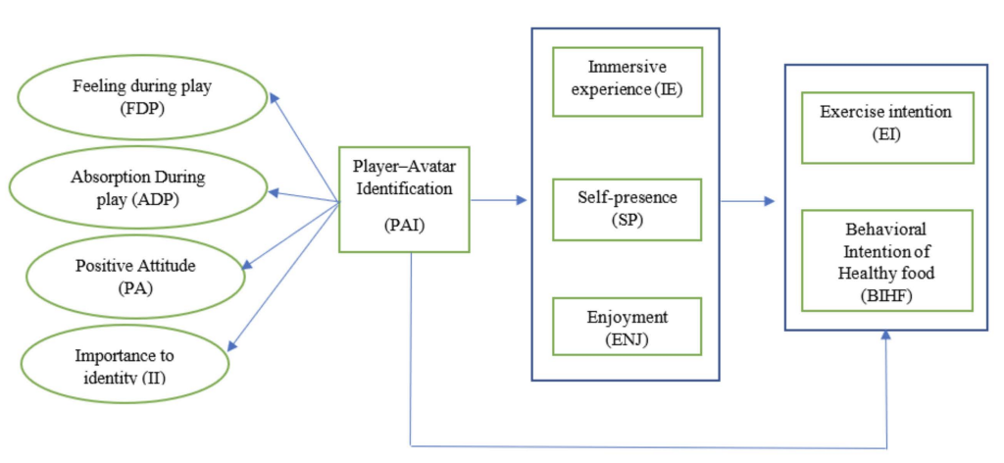

**Hypothesis**

*Hypothesis 1a.* PAI positively connected with exercise intention.

*Hypothesis 1b.* Player-avatar identification (PAI) is positively associated with healthy food intention.

*Hypothesis 1c.* Player-avatar identification (PAI) is positively associated with immersive experience.

*Hypothesis 1d.* Player-avatar identification (PAI) is positively associated with self-presence.

*Hypothesis 1e.* Player-avatar identification (PAI) is positively associated with enjoyment.

*Hypothesis 2a.* Immersive experience mediates between player-avatar identification and exercise intention.

*Hypothesis 2b.* Immersive experience mediates between player-avatar identification and healthy food intention.

*Hypothesis 3a*. Self-presence mediates between player-avatar identification and exercise intention.

*Hypothesis 3b*. Self-presence mediates between player-avatar identification and healthy food intention.

*Hypothesis 4a.* Enjoyment mediates between player-avatar identification and exercise intention.

*Hypothesis 4b.* Enjoyment mediates between player-avatar identification and health food intention.

**Methodology**

*A study with 250 students.*

The scales and items are adapted from prior relevant studies. For this study, the MMO game genre was chosen. The game chosen for this study was PUBG. The data was collected from the respondents who have had less than one year of experience in gaming, especially related to the MMO game genre. The reason for not choosing respondents with high gaming experience was that this study related to those gamers who may be influenced by gaming avatars to have a healthy lifestyle and be motivated by their avatars. The data collected from survey invitations on WeChat, QQ and Weibo social media platforms with a 43-item scale. There were a total of 287 respondents based on a convenience sampling technique. However, a total of 250 respondents were included after the responses were carefully screened, demonstrating an 87% response rate. The data mainly are taken from university students during the university’s ongoing semester. Of the respondents, 161 = 64% contributors were male and 89 = 36% contributors were female. About 83% of the responses came from bachelor students who were 18–25 years old.

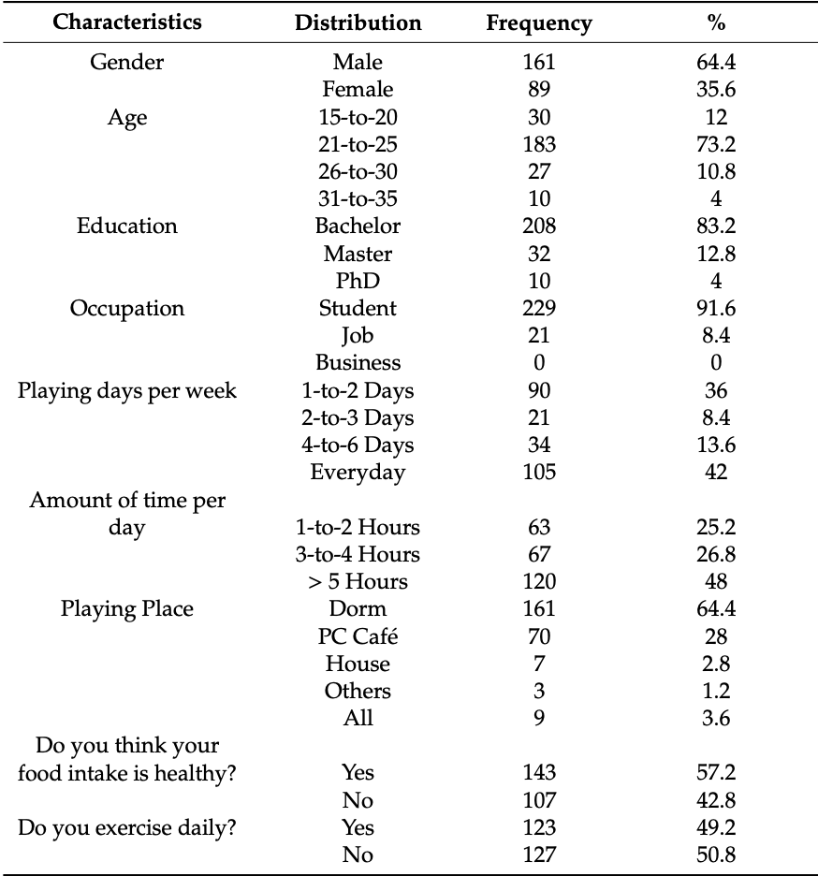

The data examined using SmartPLS 3 and proposed hypotheses tested through SPSS 21. The SmartPLS was cast off to assess and construe the SEM model; however, SPSS gaged to understand descriptive analysis, including Skewness and Kurtosis (S&K). Finally, the structural equation model (SEM) was applied to explore the relationships among the player-avatar identification, an immersive experience, the self-presence, the enjoyment, exercise intention and the behavioral intention for healthy food.

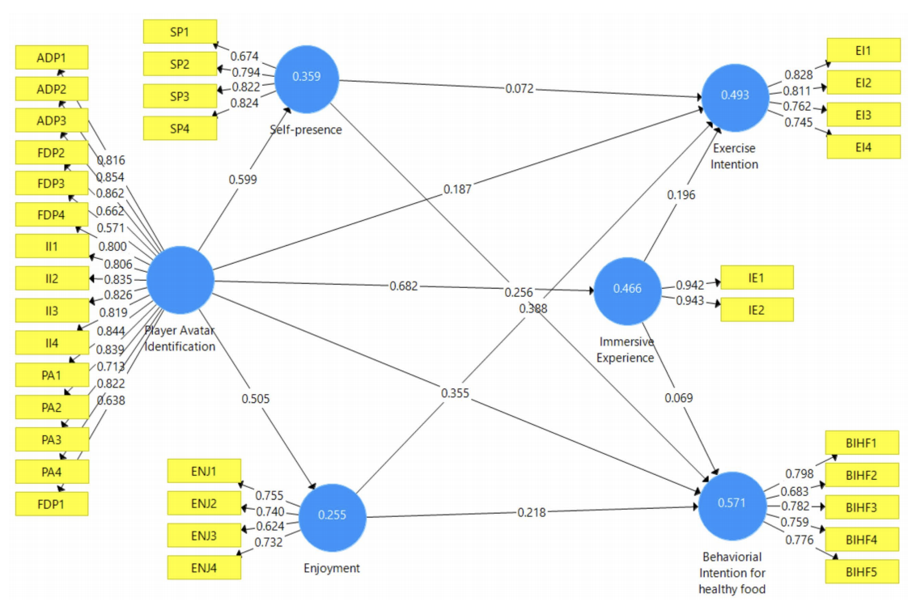

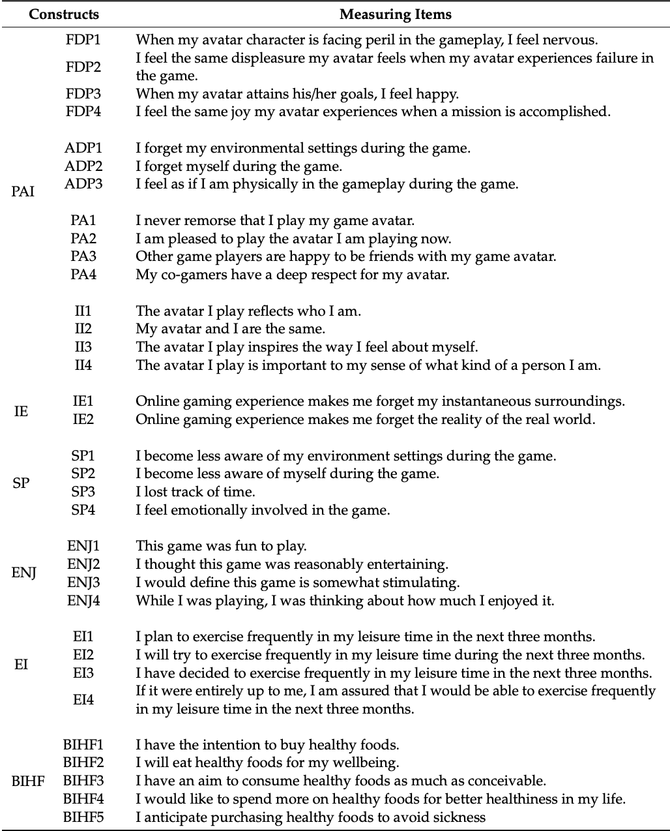

**Discussion and Implications**

*Findings and Theoretical Implications*

The study demonstrates that PAI has a bearing on consumer behavioral intention to do exercise and focus on healthy food. Preceding research has revealed, associated with neuro study, that consumers with penetrating cognitive involvement resemble the level of intimacy one experiences when interrelating one another, and users of the avatars love their character identity when they interact. Thus, this study supports PAI and its effects on consumers’ intentions. In the study, only two hypotheses did not support, whereas the rest of the hypotheses accepted with the mediation. The previous study has shown that MMORPG games have made gamers addicted to it and thus disturbing their daily life in the form of unhealthy routine and unhealthy habits among college students. MMORPG affect their lives, both physically and psychologically, every day due to game addiction. Furthermore, studies have shown that MMORPG affects youngsters with their social life, where they are so much addicted to the game that they start believing that online social interaction is the same as real-life and thus start feeling online gaming, especially MMORPG as a means of escapism from reality.

From the results, it inferred that users’ perceived immersion as not an essential factor when it came to healthy food, whereas for exercise intention, it was ok. Consumers do get involved in gameplay depending on different environmental factors such as graphic and sound quality. Perhaps, it requires further study to explore its true potential towards the consumer behavioral intention as the key is the quality of the gameplay that can make a player interact more with its avatar. In the future, immersive experience is essential, and consumers do get involved, but perhaps in a controlled experimental environment, it can provide better results.

*Implications for Game Developers*

More consumers are concerned about the avatars, and more consumers are satisfied with their life can help develop better identification. The game developer companies can work on producing more real life-like avatars that players can associate themselves with. Gaming itself is a fantasy, and so are the avatars, but consumers feel and believe they are part of their avatars and sometimes fully immersed in the character. More real life-like avatars in games can indulge gamers more to play and even learn and adopt good habits from such avatars. MMORPG and RPG games have different styles and avatar identification, which is more unrealistic. More realistic avatars may influence gamers more to be like them. Thus, not just emotionally be part of it, but can also be physically a part of it by transforming oneself into gaming avatar physical looks.

**“Celebrity Avatar”**

Monotonized game options are the concerning strategies for the companies to make money. The players like to buy attire, level-ups, currencies, and so on for their avatars. Big brands also try to understand celebrity associations, and previous studies relate to celebrity characters and celebrity congruence. The study will explore the new construct of celebrity avatar (CA) and its effect on consumer behavioral intention toward the game items.

The gamers observe that the better the avatar’s personality looks, the better they will feel bonded with it and enhance game performance. So, the players are ready to spend money on their avatar and its in-game features to make their game live better. Reliable avatars are more likely to be favored for illustration in the game atmosphere, and such avatars may influence consumers toward social, behavioral aspects also. Thus, the option of playing ones’ favorite celebrity as an avatar will entice consumers to get involved more in the game and spend more money in the game.

**Self-Brand Connection (SBC) and Self-Congruity Theory**

SBC and self-congruity theory are discussed in the view of CA. Consumers consider a brand essential and believe their possessions to be their extended selves. Thus, consumers show behavioral intention in the form of purchase or repeat purchase with loyalty, relating to the brand story. More a consumer has a positive experience with a brand online and offline, the more chances are consumers’ purchase intention and connection with it. Consumers who have a high association with a brand can also associate with a CA concept. We can assume that SBC will have a positive effect on CAs. Like SBC, the self-congruity theory explains how a consumer perceives the importance of a brand’s symbolic value and oneself. Gaming avatars and celebrity brands together as one identity can create a mental connection between the avatar and the gamer.

**Fantasy**

Fantasy is an illustration of an individual’s mind where they can be anyone or do anything or the creation of dreams that escape an individual from reality. In a fantasy world, one can escape from the real world’s worries. The reason is that it is a make-believe world in this “digital world” of gaming. Thus, games can be considered an incentive for imagination and creativity. CA can positively affect the gamers because of fantasy, and perhaps consumers may be more connected to their avatar and the brand altogether. Online video games are a source of escape for people who want to be far from reality. More gamers are immersed in the gaming world with their avatars, more likely to have a high intention to play and buy in-game features.

**CA and Player-Avatar Identification (PAI) Theory**

The term “identification” had different names from different researchers. The connotation of it is that where an individual fully immerses himself in the virtual world and believes that whatever is happening to the character is happening to himself. Avatar is changed from a regular avatar identification to CA identification. CA can affect the consumption value theory, which has four significant dimensions that are enjoyment value, character competency value, visual authority value, and monetary value. Here, we need to understand what a brand is and how it benefits the consumers and the company. A brand can be a name, a logo, a design, a sound, a term, a word, or it can be a combination of all these. In the same way, a celebrity also has characteristics. Celebrity characteristics with the avatar can be used as a CA in this research work. Consumers may be influenced by a celebrity’s lifestyle and would like to impersonate them. Celebrity endorsement can have a positive effect on the consumer's intention to buy the brand, and it also enhances the image of the brand. Celebrity and avatar together as CA may influence consumer behavioral intention to buy virtual game items. The studies have shown that virtual items help the consumer get more linked and emotionally involved with the avatar.

Companies’ strategy has changed from pay-to-play to play-to-pay. Furthermore, a new policy called freemium has been introduced (a mix of free and premium). The strategy is about playing for free, but to use some added features, a consumer needs to pay for it to enjoy the privileges, and thus, intention to play may affect the plan to pay.

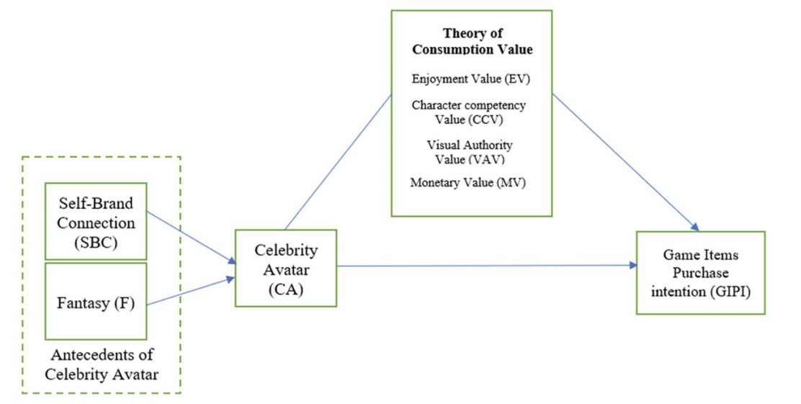

The player’s motivation to purchase virtual game items is categorized into two types: (a) functional or contributory props and (b) ornamental or expressive accessories. The functional prop can help a player in making its avatar more powerful or superior. In contrast, the decorative prop can help make the avatar’s appearance more likable and attractive. Players are inclined to devote money to boost the avatar value that may help them perform. The induction of CAs may increase consumers’ purchase intention who hardly or never buy virtual game items.

**Theory of Consumption Value (TCV)**

According to the theory, the dimensions of TCV are condition value, epistemic, functional value, social value, and emotional value. Later, the approach was modified for gaming purposes to contain four dimensions. The four dimensions are enjoyment value, character competency value, visual authority value, and monetary value. TCV advocates that consumers ascribe different values to different products, and ultimately influence purchase intention.

The enjoyment value states that gamers will acquire the virtual game items to have more entertainment with their avatar and the game itself. The character competency value indicates that the players will buy game items to uplift their avatar’s supremacy in the game. The visual authority value states that the gamers will obtain the virtual game items to embellish their avatars to increase their social positioning amid other players and social groups. The last dimension is the monetary value, where gamers will purchase in-game items as they believe it is not expensive to buy. Compared with the TCV, the enjoyment value is like emotional value, character competency value is associated with functional value, visual authority value is associated with social value, and the monetary value is the new addition in theory related to gaming.

**Hypothesis**

*Hypothesis 1.* SBC has a positive effect on CA.

*Hypothesis 2.* Fantasy has a positive effect on CA.

*Hypothesis 3a.* CA has a positive effect on consumption value.

*Hypothesis 3b.* CA has a positive effect on game items purchase intention (GIPI).

*Hypothesis 4a.* Consumption value has a positive effect on GIPI.

*Hypothesis 4b.* Consumption value mediates between CA and GIPI.

**Methodology**

The data were collected from those who currently played MMORPG, RPG, and MMO genre games. The data were collected with a convenience sample technique on WeChat and QQ social media apps. The questionnaire had a 43-item scale, including 12 demographic questions. In total, 250 respondents were included after the responses were carefully screened, demonstrating a 90% response rate.

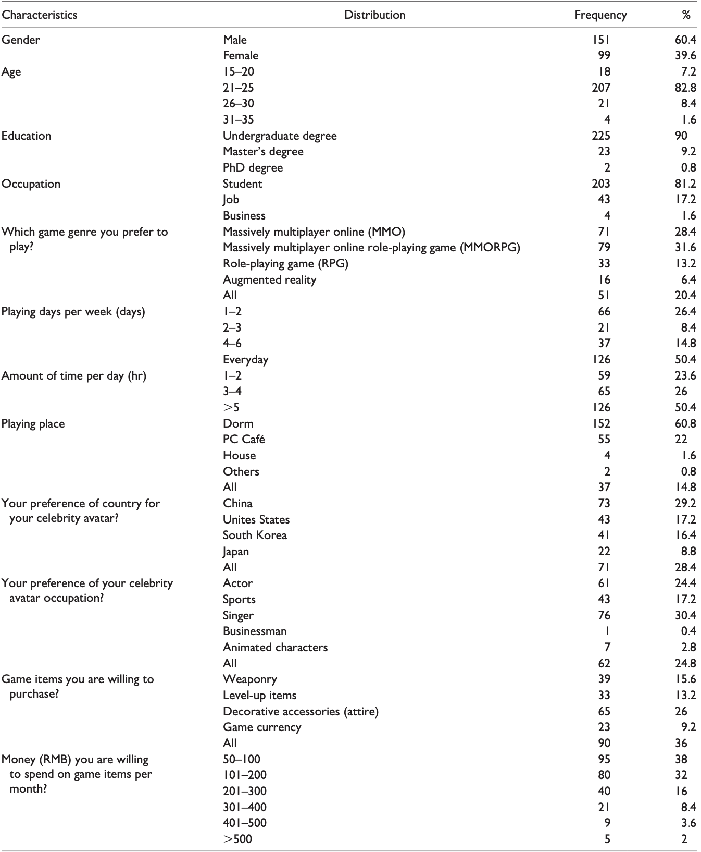

**Analyses**

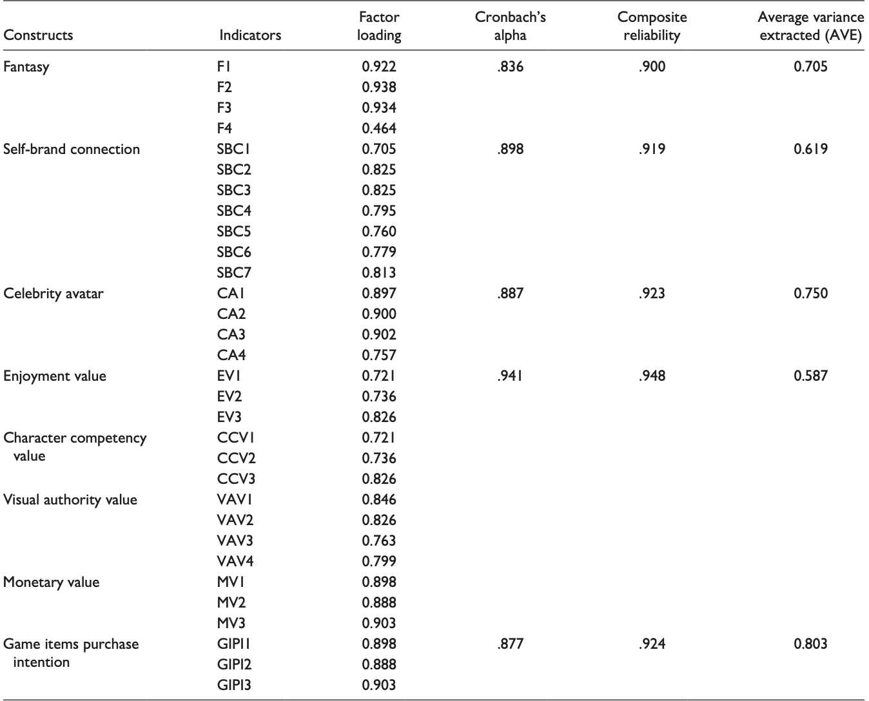

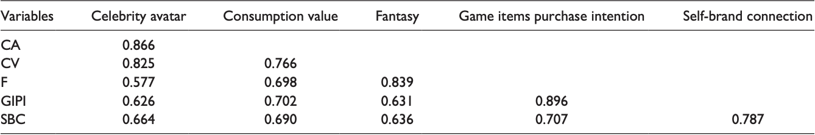

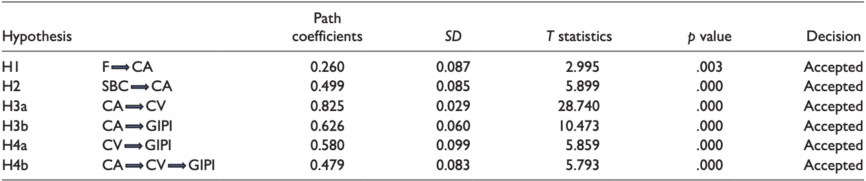



**Discussion and Implications**

*Findings and Theoretical Implications*

In this study, the TCV works well as a mediator for CA and GIPI. So, the scales for SBC, fantasy, CA, TCV, and GIPI are appropriate tools to assess this framework regarding online video gamers.

Hypotes 1 stated that SBC positively affects CA as previous studies show that avatar identification and SBC are positively associated. Thus, it indicates that gamers are closely linked with CAs. It is understandable from the results that players are influenced by CA as mentioned in previous studies that celebrities influence the consumers, and in the form of CA, it gives a more positive connection to themselves.

Hypotes 2 stated that fantasy has a positive effect on CA and was approved. The reason for its acceptance is that gamers feel that they can do anything when they are in a fantasy world. Thus, gaming provides them with that platform where they can be what they dream.

Hypotes 3a states that CA has a positive effect on consumption value. This hypothesis is approved. We know celebrity endorsement influences consumers with their charismatic personality. And the PAI and the gamer are immersed in the gaming experience; thus, CA as seen from the structural model analysis effects TCV. It affects enjoyment value, character competency value, visual authority value, and monetary value positively.

Hypotes 3b states that CA has a positive effect on GIPI. This hypothesis is also approved. As discussed before, celebrities do influence the consumers, and avatars are customized in accordance with one’s personality while playing. Thus, CAs may influence consumers more from standard avatars in buying in-game items to increase avatar performance.

Hypotes 4a states that consumption value has a positive effect on purchase items. This hypothesis was also accepted. The structural model analysis shows that gamers tend to believe that they will get more out of the avatar and will buy more virtual game items to make the avatar look and perform better. Gamers will purchase game items when they feel that their avatar enjoyment value is high, the avatar is highly competitive in the gameplay, the avatar’s appearance is per their reflection, and the monetary value attached to the avatar is reasonable.

Hypotes 4b stating that consumption value mediates between CA and GIPI is also approved. Thus, TCV is mediating well with the new construct CA and GIPI. In the previous study, TCV was used to directly affect the intention to play. In this article, we have taken TCV as a mediator. The results were entirely up to the constructs in the framework. We see that the mediation effect is more than the direct impact of CA on GIPI.

Finally, this study suggests that CA a new construct increases consumer intention to pay for in-game items with the mediating effect of TCV. These insights provide details to game developers to develop games where they can give CA options, and thus, it may influence consumers to play more and pay more to enhance the ability of the gamer’s avatar in performance and appearance both. More customizations are available for the players in the form of CA; more likely are the chances for them to buy more in-game items. Thus, the new construct CA has value and can earn money for game developers if implemented.

*Implications for Game Developers*

CA in the MMORPG game genre. This study shows that CAs can influence consumers in buying in-game items through the mediating effect of TCV. CA itself is a new construct. Previously, avatar has been used by different names as PAI and so on but not as a CA. This new construct can add value to the game if game developers choose this option in their gameplay. Game developers spend millions of dollars on developing games, and thus, using celebrity as an avatar can help both the company and the celebrity itself. CA in AR games. There are different types of game genres available to the consumers to enjoy, such as MMORPG, MMO, and RPG. There is one more term as AR. AR games provide learning, socializing, brain development, and healthy activity for the gamers. The CA concept can also be highlighted in AR-based reality games.

**Marketing**

**It seems that research in marketing has concentrated on two types of avatar.**

**Model-avatars**

The interest of these particular avatars can be explained by their explicit utility on sites specialized in online sales of clothing (Nantel, 2004), and also by their entertainment value (Kim and Forsythe, 2008, 2009; Malter, Rosa and Garbarino, 2008). They provide an answer to the absence of touch (Rosa, Garbarino and Malter, 2006) and the lack of direct experience of online purchases (Crete et al., 2008). They are therefore highly realistic (Merle, St-Onge and Senecal, 2011; Suh, Kim and Suh, 2011) and raise questions about the relationship of consumers to their bodies in a virtual context (Malter, Rosa and Garbarino, 2008; Merle, St-Onge and Senecal, 2009, 2011)

**Avatar inhabitants of virtual worlds simulating life**

The special attention researchers have paid to virtual universes such as SL is essentially justified by their commercial interest5 (purchase of virtual products, presence of virtual brands, products or stores). Most of the questions deal with the identity construction and symbolic of the representation of an individual (Vicdan and Ulusoy, 2008; Parmentier and Rolland, 2009; Rhee, Sanders and Simpson, 2010; El Kamel and Rigaux-Bricmont, 2011) and with the purchase of virtual products (Chung, 2005; Hemp, 2006; Jin and Bolebruch, 2010; Animesh et al., 2011). Indeed, in these universes, as in games, one of the most important activities consists of buying virtual goods and accessories that construct the character in question, equipping him/her with clothes, accessories and arms, and/or personalizing him/her through hairstyle, changes to body shape, powers and/or skills. According to Greengard (2011), 21% of internet users buy or exchange virtual goods. Often, these virtual goods are a precise representation of a real product that inhabitants can buy for their avatar or ‘for real’. In the first case, the avatar is the subject of the consumption (El Kamel and Rigaux-Bricmont, 2011), whereas in the second, he/she is the mediator. Both cases raise the question of the effect of this intermediation on the consumer decision-making process. We should also mention the emergence of studies such as those of Garnier and Poncin (2009) and Poncin and Garnier (2010) on 3D shops/shopping malls; these studies deal with questions related to avatars in the context of virtual commercial reality. However, the use of avatars is far broader than the reach of anything studied by marketing so far, and there are still many managerial and research perspectives concerning questions associated with avatars, consumption and the commercial context.

Any commercial context involves specific concrete consequences: purchasing a real product with home delivery, financial transaction, contacts and relationships with the company, social relationships among consumers and also the wish to visit the commercial, cultural or touristic destination ‘for real’. Besides their obvious useful aspect, 2D and 3D internet sites may comprise pleasurable, social and ‘fun’ aspects: the pleasure of online shopping, entertainment, social interaction through discussions, etc. The virtual commercial context can thus have real implications for the purchase itself and for commercial and/or social relationships. Representation through an avatar is thus not only a parallel life that is unconnected from the individual’s real life – it can also have a concrete impact on reality. This gives rise to a great many avenues for reflection and further research on avatars. Indeed, it is important to question about the impact of such intermediation on traditional consumer behaviors (decision and purchasing processes, post-purchase attitudes and behaviors, relationships with companies), and in the first place to question about the central role of the creation and identity embodiment in a virtual body and the consequences of this for the experience of online consumption. These areas cover essential questions both for marketing practitioners and academics.

**Studying avatars in a context of online shopping.**

What identity strategy will an individual adopt when window-shopping in a virtual shopping mall? Can the company leverage this strategy in its proposals for personalization? What identity strategy will be adopted for visiting a virtual museum? In as much as most current studies use preconceived avatars that are imposed on participants, a deeper study of individuals’ own personalization process and its consequences seem necessary. The particular nature of the commercial context (compared to games or SL) is that the individual generally has only one account, and thus only one avatar through which the whole of the identity dynamic will be expressed. These questions thus open different perspectives for research on the influence of avatar creation on the expected commercial relationship: (1) research that tests different offers of levels and attributes of personalization with different possibilities for self-representation (realistic or fanciful); (2) research that tests the impact of non-human embodiment in a commercial universe and on different levels of usefulness/entertainment (for example, a shop vs. a museum); (3) research that manipulates the objective of shopping (utilitarian vs. social vs. entertaining) and estimates the effect on avatar design; (4) longitudinal research on the use of the same avatar, observing its creation, related motivations and eventual modifications in a dynamic of identity linked to consumption. Finally, certain personalization tools might include product/brand placement (similar to product placement in games (Lehu and Bressoud, 2008)) on the avatar’s clothes or accessories; another interesting approach would be one linking avatar, identity and brands. What attitude do individuals have towards this process? How far do brands and products participate in the expression of an identity through an avatar (Jin and Bolebruch, 2010)? Are these similar to the strong links between identity and consumption widely identified in non-virtual contexts (Belk, 1988)? What is the impact of these relationships that are expressed and created in a virtual world on real-world consumption, and on the real relationship between the individual and the brand?

Avatar-based marketing is still in its nascent stage. Consequently, marketers need help designing strategies for successful marketing applications.

Based on this definition, we present a typology of avatar design to isolate elements that academics and managers can leverage to ensure avatars’ effectiveness for achieving specific goals (e.g., providing standard vs. personalized solutions). Different design elements cause avatars to vary in their visual appearances and behaviors during interactions with humans. All design elements affect avatars’ form realism and behavioral realism. Form realism refers to the extent to which the avatar’s shape appears human, while behavioral realism captures the degree to which it behaves as a human would in the physical world. Form realism includes design elements such as spatial dimension (2D/3D), movement (static vs. dynamic), and human characteristics (e.g., name, gender), whereas behavioral realism captures the avatar’s communication modality (e.g., verbal), response type (scripted vs. natural response), social content, and its controlling entity.

Our review of extant literature and business practices reveals a key limitation: lack of consideration of the alignment between form and behavioral realism of avatars. If the levels of form and behavioral realism are mismatched, the consequences for avatars’ effectiveness may be profound and can help explain inconsistent avatar performance.

Integrating form and behavioral realism, we produce a 2 x 2 avatar taxonomy that identifies four distinct categories of avatars: simplistic, superficial, intelligent unrealistic, and digital human avatars. A simplistic avatar has an unrealistic human appearance (e.g., 2D, visually static, cartoonish image) and engages in low intelligence behaviors (e.g., scripted, only task-specific communication). For example, in the Netherlands, ING Bank’s 2D, cartoonish-looking avatar Inge responds to simple customer inquiries from a set of predetermined answers. In contrast, a superficial avatar has a realistic anthropomorphic appearance (e.g., 3D, visually dynamic, photorealistic image), such as Natwest Bank’s Cora, but low behavioral realism in that it is only able to offer preprogrammed answers to specific questions. An intelligent unrealistic avatar (e.g., REA) is characterized by humanlike cognitive and emotional intelligence, but exhibits an unrealistic (e.g., cartoonish) human image. These avatars can engage customers in real-time, complex transactions without being mistaken for human agents. Finally, a digital human avatar such as SK-II’s YUMI is the most advanced category of avatars, characterized by both a highly realistic anthropomorphic appearance and humanlike cognitive and emotional intelligence, and is designed to provide the highest degree of realism during interactions with human users.

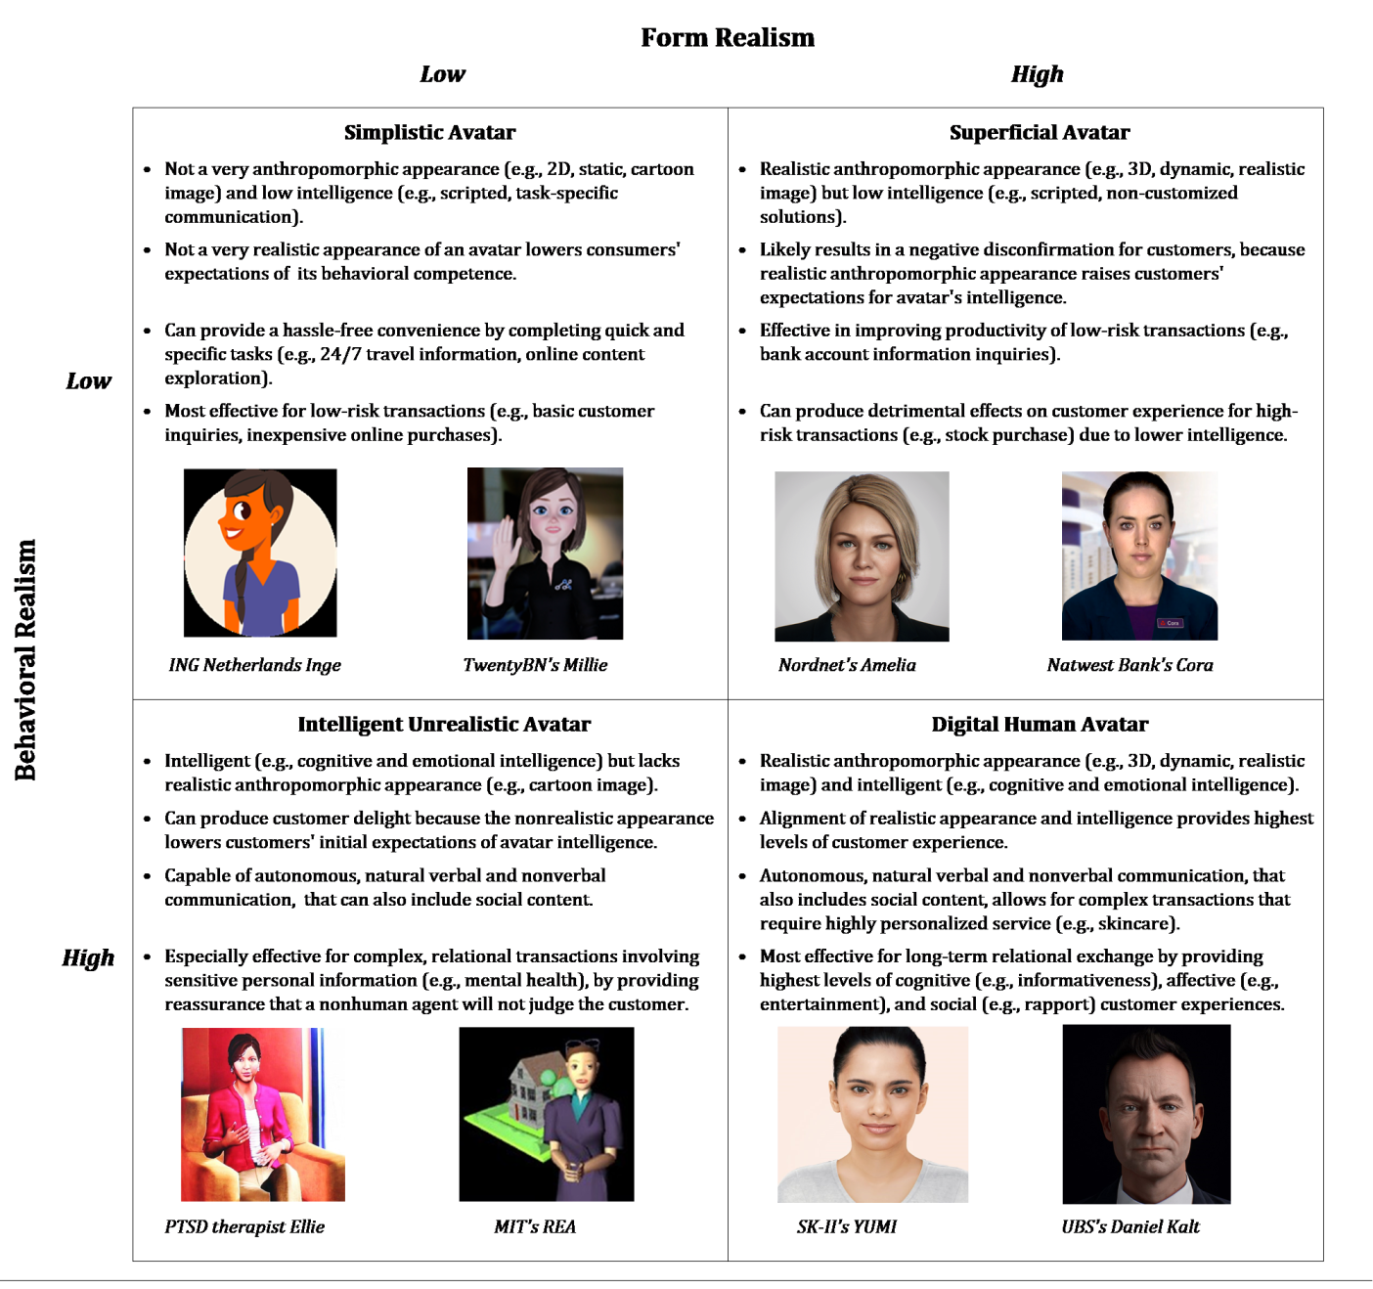

**Military and Training Systems**

**Research questions and hypotheses**

**RQ1: Does self-representation through self-created avatars enhance avatar creators’ sense of self-preservation?**

**H1: Avatar creators will show a higher sense of self-preservation than non-avatar creators.**

Avatars afford us an opportunity to see ourselves in the third person. It helps users identify with their avatars

Another possible psychological mediator to predict the avatar users’ psychological and behavioral outcomes is the sense of agency (i.e., feeling control over something) which would be enhanced by customizing their avatars. Therefore, it is hypothesized that a sense of self-presence and/or sense of agency would mediate the relationship between avatar customization and avatar customizers’ sense of self-preservation.

RQ2: Does self-representation through self-created avatars enhance avatar creators’ sense of self-preservation by influencing their sense of self-presence and sense of agency?

H2a: Sense of self-presence will mediate the relationship between avatar customization and avatar creators’ sense of self-preservation.

H2b: Sense of agency will mediate the relationship between avatar customization and avatar creators’ sense of self-preservation.

The research questions and hypotheses above, attempts to find the key factors that predict avatar users’ psychological and behavioral outcomes (i.e., sense of self-preservation). As we know, the avatar as a form of self representation is closely connected to the self. As such, the process of customizing an avatar is expected to provide the opportunity for a user to realize the self and observe the self as an agent from a third-person perspective. Therefore, it is predicted that the agency enhanced through avatar customization will cause users to behave in ways to preserve themselves. Another line of research suggests that users’ behaviors can be influenced by their avatars’ physical attractiveness. In Yee and Bailenson (2007) study, when users were given attractive avatars as forms of self-representation, they behaved in confident and friendly ways. To test these two competing theoretical propositions, this dissertation employs a between subject experimental design with avatar customization/non-customization groups for which the avatars’ attractiveness in the non-customization condition was manipulated.

In conclusion Technologies like Virtual Reality would have a bigger role to play. Within seconds you can create your own human-like avatar, enter into a virtual room with friends, and watch movies or play games. Undoubtedly, the potential is endless and in the near future, one can predict that the avatars may replace photographs and become immortal communication objects for generations to come.

Conclusion. Virtual humans are rapidly emerging in many state-of-the-art complex virtual reality systems for the purpose of educating users in social inter-personal skills that are perhaps novel, stressful or repeatable in simulated face-to-face scenarios. These virtual human simulations need to be highly realistic, engaging, compelling and affect provoking in order to accurately simulate real-life situations for the purpose of training and education. Let's check some examinations of the importance of visual realism of virtual humans on affective reactions in a simulation interpersonal interaction with a deteriorating patient over the four time-steps simulation of a patient surveillance scenario in a nurse’s shift. To our knowledge, this research is one of the first in empirically examining the role of realistic versus stylized appearances of a virtual human in a dynamic virtual reality simulation on positive and negative affect reactions of users. We also found that the visual realism of the virtual human had a significant effect on participants’ positive and negative affect reactions. Our research suggests that developers of affective agents in VR simulations for entertainment as well as goal-oriented interactions should pay careful attention to the visual realism of the interactive virtual humans as they may have a strong impact on emotional reactions of learners.

They created an Avatar-based game specifically designed to improve the cultural understanding of US Army personnel prior to their deployment to Afghanistan. These built the avatar-based game with VBS3, a platform currently used by the U.S. Army for tactical training. Working with experts in the different Afghani cultural groups, they repurposed the VBS3 gaming platform to produce an avatar-based game built around two scenarios: a market and a local council of leaders. They validated the dialogue in these scenarios with the subject matter experts.The design of experiments allowed them to test two hypotheses: 1. Training cultural skills through game-based simulations improves cross-cultural competence; and 2. Game-based simulations with reverse perspective taking improves cross-cultural competence compared with standard training. They recruited 60 participants for this study.

Results show that training with the avatar-based game significantly (

𝑝<0.01

p<0.01) improves understanding of Afghan culture to the level where they can interact in two different scenarios versus participants who received only simple video-based training. This improvement is measured by dialogue decision making across four cultural dimensions. Participants who used the avatar-based game also self-assessed themselves as having greater understanding.

The results here also show that in contrast to previous research, perspective-taking did not significantly improve trainees’ dialogue decision making in the new cultural setting. Additionally, perspective-taking actually reduced the interest by participants in learning about the other culture. They also found that enjoyment of the simulation depended on the type of scenario and associated cultural dimensions used for perspective-taking.

Overall the results in this paper reinforce and add to our understanding of the development and use of avatar-games for cross-cultural training. They suggest that game-based approaches have tremendous potential to improve cultural understanding by employees, and, as such, they can help ensure effective interactions in these complex environments. This approach is obviously scalable to other countries and cultures.

There are a number of limitations to this work and our results that suggest areas for further study. First, the scenarios and accompanying dialogues in this version are simple and explore only basic cultural concepts in four of Trompenaars’ seven cultural dimensions. This needs expansion.

A related problem is that the VBS3 platform is not designed for the types of interactions needed to fully visualize and play with the complexities of cross-cultural interactions. What is needed are more realistic and believable avatars capable of appropriate non-verbal as well as verbal communication. This will allow for a much richer set of scenarios and interactions, and potentially provide for deeper and more lasting cross-cultural understanding. This suggests that we need to use the results from this work to refine the selection criteria in Table 1 to weight more heavily the complex characteristics needed for cultural simulations and give less weight to rapid development and ease of integration into current military systems. Clearly, there are significant trade-offs involved in these design decisions.

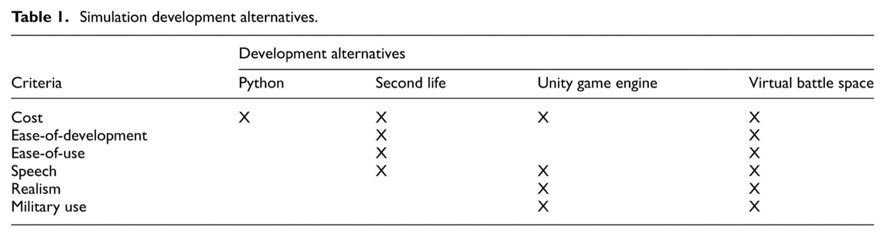

Another problem is that this study compared an avatar-based game system for cultural training to short training with videos. While these videos have some similarity to the current training, they are not the same. A more complete comparison needs to be done with one or more of the more commonly used current methods for cultural training, such as, pamphlets, power point lectures, and other approaches as enumerated in Tebo’s work.[9](https://journals.sagepub.com/doi/10.1177/1548512918807593) At an even more basic level, the training times should be equalized, and perhaps even biased in favor of the non-game-based controls, rather than the other way as was done here.

This work is also not the final answer on perspective-taking. The results suggest that its effectiveness will be scenario dependent. Work is needed to discover the scenario characteristics that produce good outcomes.

Another area for future work is the development of three-dimensional immersive games. These systems have the potential to enable more realistic gestures and more coordinated sound to facial movement. An immersive system that quantifies personality, emotion, attitude, and social awareness, then applies social filter rules, may contribute to more believable avatars, and, therefore, result in more valuable cultural training.

**Top avatars companies**

**1.** [Twindom](https://www.ventureradar.com/organisation/Twindom/b9de299f-d154-4c14-b4ee-63f34549d127)

This company began as a 3D printing vending machine manufacturer called Dreambox. After sensing a stronger long-term viability for capturing and printing individuals and essentially revolutionizing the concept of photography, we re-branded, re-focused, and named ourselves Twindom. We currently capture participants in 3D using a mobile scanning setup similar to a photo booth, and then print their scans at several miniature scales in full-color sandstone.

**2.** [Bold Metrics](https://www.ventureradar.com/organisation/Bold%20Metrics/882a20d3-2529-4202-93d5-816a3364bfb4)

As the leading AI-powered solution for apparel retailers and brands looking to reduce returns, improve sustainability, and boost conversion, Bold Metrics AI Body Modeling technology helps brands unlock the power of customer body data to meet the demands of today's increasingly personalized world. Bold Metrics AI Body Modeling technology instantly captures the human form in detail. No measuring tape or photos required. Using advanced AI to accurately determine critical points of measure and body contours to create unique 3D models, each with over 50 individual body measurements. Bold Metrics best-in-class AI Body Modeling technology powers 3D body data capture at scale.

**3.** [Gameware Europe](https://www.ventureradar.com/organisation/Gameware%20Europe/10aa9584-dce6-430a-9472-ada49ffc3705)

Over several years GWE has iteratively developed a photo-realistic real-time 3D avatar technology which is an extension of their development work within the EU H2020 ‘RAGE’ project.The avatar technology supports the visualization of human/electronic interaction for training purposes.GWE has also been working alongside an established distance training provider on a software authoring tool designed to enable content developers and subject matter experts to create text and/or speech-based scripts which can simulate one-to-one conversations of virtually any description in order to generate interviews, appraisals and needs assessment scenarios.

**4.** [Venu](https://www.ventureradar.com/organisation/Venu/bae75d84-fce8-4c1f-a836-cccb1507a7e1)

Venu is a true-to-life, immersive 3D virtual trade show /conference platform for event organizers to engage and delight attendees, allowing avatars to walk around, in first person view, to spontaneously connect, showcase products / solutions.

**5.** [Loom.ai](https://www.ventureradar.com/organisation/Loom_%5bdot%5d_ai/dae4d77a-9c9a-409b-9b2e-9fa96a617fdd)

We are excited and proud to announce that the Roblox Corporation is acquiring Loom.ai. Our team will be joining Roblox's vision to bring the world together through play by bringing real-time and real-life emotions to the Roblox metaverse.

The opportunity to build real-life facial expressions for the millions of Roblox players is a dream come true. In the future, Roblox players can imagine watching their favorite music artist singing with facial expressions during a virtual concert or interacting with friends in a life-like, interactive way. The expression of emotions that will be brought to life by the Roblox community is limitless.

**6.** [Ovio Technologies, Inc.](https://www.ventureradar.com/organisation/Ovio%20Technologies,%20Inc_%5bdot%5d_/149f486b-c9eb-4e13-a3f6-79d62546bf3f)

oVio Technologies has developed innovative dimensional imagery technology for AR/VR/3D applications, government & corporate global ID management, security, fin-tech, and medical/tele-medicine.​

oVio's solution creates and synthesizes true and accurate volumetric, dimensional imagery source data, which significantly improves the accuracy and performance of imaging-centric machine vision technologies such as facial recognition, and AR/VR content creation (such as avatars for gaming and other media), object recognition (tele-medicine, et al), and machine learning.​

oVio's patented 360-degree dimensional imaging technology addresses the global inaccuracy of identification management systems, computer vision search engines, authentication & fraud prevention technologies, and 3D file creation processes arising from the absence of adequate dimensional imagery source data.​

**7.** [Oben](https://www.ventureradar.com/organisation/Oben/37902fea-9e98-4175-b1f1-8b437aa0762a)

Oben is an artificial intelligence company that for the first time in the industry combines a person's 2D image and voice to create an amazingly realistic and personalized 3D virtual self that can be transported into VR/AR/IoT experiences and made social. Specifically, with just a selfie taken on any smartphone and a brief voice recording, ObEN's proprietary AI tech creates incredibly photoreal virtual selves, making this technology accessible to everyone (we are populating the world with virtual humans who tell stories, drive trends, and create experiences combining the heart of cutting-edge research with the soul of human creativity).

**8.** LiveLike

LiveLike is a technology company delivering the best live sports experiences to fans on any mobile platform. Their white label platform integrates the latest innovations in VR, AR, and MR to revolutionize sports viewing around the world. LiveLike's Social Virtual Reality feature allows multiple people to view a game together, no matter their geographic location. This feature employs 3D avatars and spatial audio so people can communicate in an immersive environment with friends in VR. LiveLike's platform powers the FOX Sports VR app, along with other major international broadcasters such as BT Sport, France TV, Webedia, and Dentsu. Past broadcasts through LiveLike include Super Bowl LI, the 2017 UEFA Champions League Final, and the French Open. Fans can view broadcaster content with or without a VR headset, allowing immersive experiences to be accessible to all with a device. Recognized...

**9.** Club Cooee

Club Cooee is a 3D internet communication platform for teenagers who want to meet in a virtual reality to have fun and be creative together. The core of Club Cooee is an innovative and worldwide unique 3D messenger capable of depicting a realtime and live environment on the user’s Windows desktop - without a surrounding programme window. The users can network online and interact with each other in situations they created themselves. They can chat, watch movies and pictures, listen to music, play together and much more. Their own creativity is top priority.

**10.** Care Coach

With care.coach, individuals can talk with a captivating avatar that serves as the face for care.coach's team of specially trained health advocates. The platform engages and coaches clients to improve self-management of chronic conditions, and provides compassionate, 24x7 psychosocial support.

​Because it is driven by real people, the platform works with any level of technology and cognitive ability, which makes it ideally suited for the types of individuals at the highest healthcare risk and cost strata.

The care.coach video visit solution is an easy to use, provider-led telemedicine app. It requires no intervention ​from the user to receive a call from their provider, caregiver, or loved one.​

**Features Include:**

* Always on Wi-Fi enabled device to ensure 24x7 availability
* Hardware configurations for tech-averse individuals
* Auto app switching when call is connecting and ending
* Auto full screen answer (optional)
* A care.coach proprietary, HIPAA-compliant platform

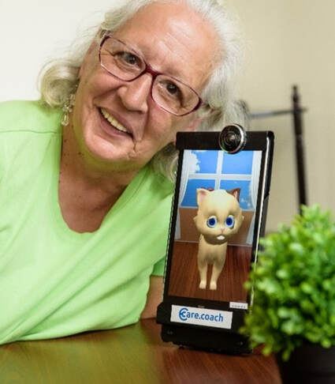

**Care Coach has the following services:**

*Health Coaching -* Software algorithms guide patients towards better self-management of chronic conditions like heart failure and diabetes, and health episodes such as joint replacement after-care.

*Psychosocial Support -* Our specially-trained, background-checked, and insured team of health advocates provide always-available, 24x7 compassionate conversation and non-clinical support.

*Automated Alerts -* Our fully customizable program specifications define under what conditions your clinical team will be automatically alerted about any issues, whether by phone or email.

*Scheduled Reminders -* In addition to generalized health coaching care.coach can schedule dietary, exercise, appointment, or other activity reminders per patient.

*Intelligent Analytics -* Our system enables us to retain highly valuable patient-generated data pertaining to weight, care plan adherence, mood, etc, and to generate simple, actionable reports.

*Telemedicine -* Our video visit product easily connects members/patients and providers/families without needing any technology skills from members, or even Wi-Fi in members’ homes!

video link (<https://www.care.coach/uploads/b/9850803-566854358188016673/cc_intro__544.mp4>)

**11.** [CLO3D](https://www.clo3d.com/explore/whyclo)

CLO3D or CLO Virtual Fashion is a fashion design company and software developer for virtual fabric design. The tools developed by CLO3D allow you to create accurate simulations of 23 types of fabric (including skin), and then put on virtual clothes on a 3D computer model of a person.

The purpose of this is to develop 3D dynamic fashion garments with changeable styles, colors and textile patterns, especially using a 3D virtual simulation system, and to examine their potential possibilities in online fashion platforms. For designing and developing 3D dynamic fashion garments, CLO3D and Aftereffects were used with a design collaboration between a fashion designer and a motion graphic artist group. Ten samples of a ready-to-wear collection were developed to visualize aesthetic and technological explorations of 3D dynamic fashion garments, composed of short videos. This study also evaluated the potential of 3D dynamic fashion garments along with 3D virtual simulation systems through focus group interviews with professional fashion designers and digital experts, which indicated social and industrial possibilities toward them. This survey showed a list of findings in terms of current status of 3D virtual simulation systems and their impact on companies, discourses on the uncanny valley surrounding avatars, changes in fashion design process derived from 3D virtual simulation systems, co-design and customization in online platforms, and future prospects of 3D virtual garments in the fashion and gaming industries. Finally, this study led to discussions on future possible digital fashion design with several implications, based on design criteria, including digital technology, dynamic range, wearability, expressivity, interactivity, sustainability, and context.